Heaven's light is our guide
Rajshahi University of Engineering & Technology

Department of Computer Science & Engineering

Sessional (Lab Report)-02

Course Name : Database Systems Sessional
Course Code : CSE 3102
Experiment No : 02
Experiment Name : Self Query generator using a database
Date of Experiment : 16 Jun, 2025
Date of Submission : 18 Jun, 2025

Submitted by :  Name : Md. Asad-Al-Adil  Roll no : 2103064  Section : B  Series : 21 | Submitted to:  Md. Azmain Yakin Srizon  Assistant Professor  Department of Computer Science and Engineering, RUET

- Create a database called “CricketerStatsDB”.

SQL Command
Create Schema CricketerStatsDB;
use cricketerstatsdb;

- Create a table titled “Players” with the following constraints.
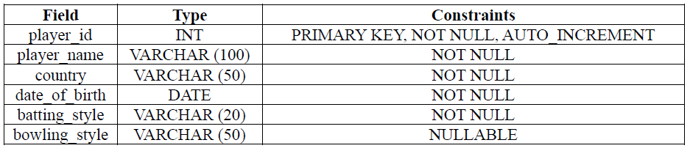

SQL Command
create table Players(
player_id INT PRIMARY KEY NOT NULL AUTO_INCREMENT,
player_name VARCHAR (100) NOT NULL,
country VARCHAR (50) NOT NULL,
date_of_birth DATE NOT NULL,
batting_style VARCHAR (20) NOT NULL,
bowling_style VARCHAR (50) NULL
);

- Create a table titled “Matches” with the following constraints.
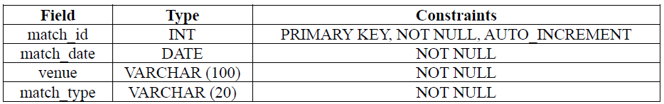

SQL Command
create table Matches(
match_id INT PRIMARY KEY NOT NULL AUTO_INCREMENT,
match_date DATE NOT NULL,
venue VARCHAR (100) NOT NULL,
match_type VARCHAR(20) NOT NULL
);
- Create a table titled “Performances” with the following constraints.
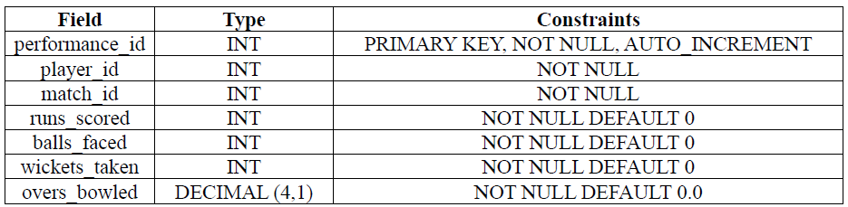

SQL Command
create table Performances(
performance_id INT PRIMARY KEY NOT NULL AUTO_INCREMENT,
player_id INT NOT NULL,
match_id INT NOT NULL,
runs_scored INT NOT NULL DEFAULT 0,
balls_faced INT NOT NULL DEFAULT 0,
wickets_taken INT NOT NULL DEFAULT 0,
overs_bowled DECIMAL (4,1) NOT NULL DEFAULT 0
);

- Populate the table “Players” with the following data
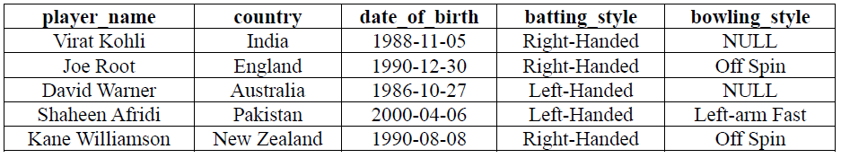

SQL Command
INSERT INTO Players (player_name, country, date_of_birth, batting_style, bowling_style)
VALUES
('Virat Kohli', 'India', '1988-11-05', 'Right-Handed', NULL),
('Joe Root', 'England', '1990-12-30', 'Right-Handed', 'Off Spin'),
('David Warner', 'Australia', '1986-10-27', 'Left-Handed', NULL),
('Shaheen Afridi', 'Pakistan', '2000-04-06', 'Left-Handed', 'Left-arm Fast'),
('Kane Williamson', 'New Zealand', '1990-08-08', 'Right-Handed', 'Off Spin');

- Populate the table “Matches” with the following data.
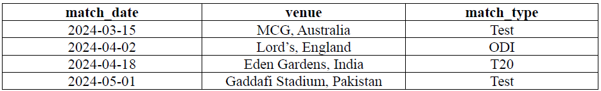

SQL Command
INSERT INTO Matches (match_date, venue, match_type)
VALUES
('2024-03-15', 'MCG, Australia', 'Test'),
('2024-04-02', 'Lord''s, England', 'ODI'),
('2024-04-18', 'Eden Gardens, India', 'T20'),
('2024-05-01', 'Gaddafi Stadium, Pakistan', 'Test');

- Populate the table “Performances” with the following data.
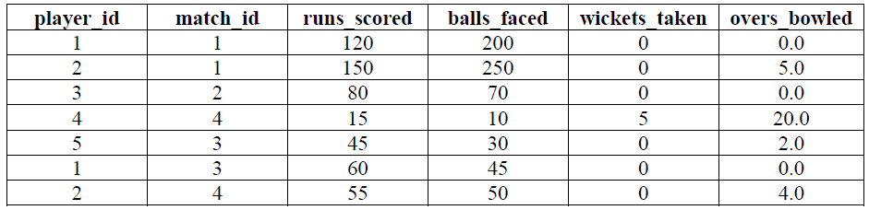

SQL Command
INSERT INTO Performances (player_id, match_id, runs_scored, balls_faced, wickets_taken, overs_bowled)
VALUES
(1, 1, 120, 200, 0, 0.0),
(2, 1, 150, 250, 0, 5.0),
(3, 2, 80, 70, 0, 0.0),
(4, 4, 15, 10, 5, 20.0),
(5, 3, 45, 30, 0, 2.0),
(1, 3, 60, 45, 0, 0.0),
(2, 4, 55, 50, 0, 4.0);

Newly Generated Queries & Output Based on “CricketerStatsDB” Database

Query-1: Show the tuple/tuples of the players whose batting style is right-handed.
select *
from players
where batting_style='right-handed'
Output:
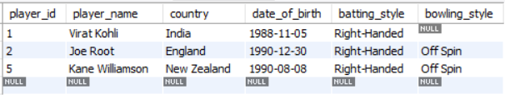

Query-2: Show the tuple/tuples of the players along with player’s age with the format like “X years Y months”. (Here X and Y are positive integer numbers.)
select *,concat(year(current_date)-year(date_of_birth)-1,' years ', month(current_date)-month(date_of_birth)+12,' months ') as age
from players
where month(current_date)-month(date_of_birth)<0
union
select *,concat(year(current_date)-year(date_of_birth),' years ', month(current_date)-month(date_of_birth),' months ') as age
from players
where month(current_date)-month(date_of_birth)>=0
Output:
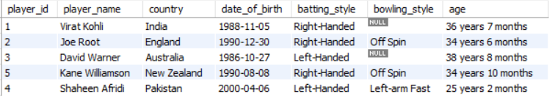

Query-3: Show the player id, player name, total runs, total ball faced and strike rate in a table from maximum to minimum
select player_id,player_name,sum(runs_scored) as Runs,sum(balls_faced) as Balls, sum(runs_scored)/sum(balls_faced)*100 as Strike_Rate
from players natural join performances
group by player_id
order by Strike_Rate desc
Output:
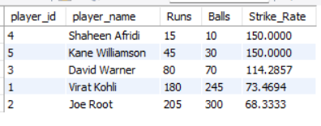

Query-4: find the total runs scored in test cricket format.
select match_type, sum(runs_scored) as Total_runs
from matches natural join performances
group by match_type
having match_type='test'
Output:
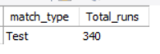

Query-5: Find the id, name of the player who has scored maximum runs in T20 in a single match.
select player_id,player_name,runs_scored
from matches natural join performances natural join players
where runs_scored=
(select max(runs_scored)
from matches natural join performances
where match_type='T20'
)
Output:
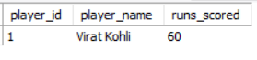

Query-6: Show all the data of the last match
select *
from matches natural join performances
where match_id=
(select match_id
from matches
order by match_date desc
limit 1)
Output:

Query-7: Show all the data where the venue country is Australia or Pakistan
select *
from matches natural join performances natural join players
where venue like ('%Australia%') or venue like ('%Pakistan%')
Output:
